ASSIGNMENT - 11

**CSP - 554 BIG DATA TECHNOLOGIES**

## Worth: 5 points (1 point for each problem)

## Exercises

Exercise 1)

**Commands:**

create ‘csp554Tbl’ , {NAME=>‘cf1’} ,{NAME=> ‘cf2’}

describe ‘csp554Tbl’

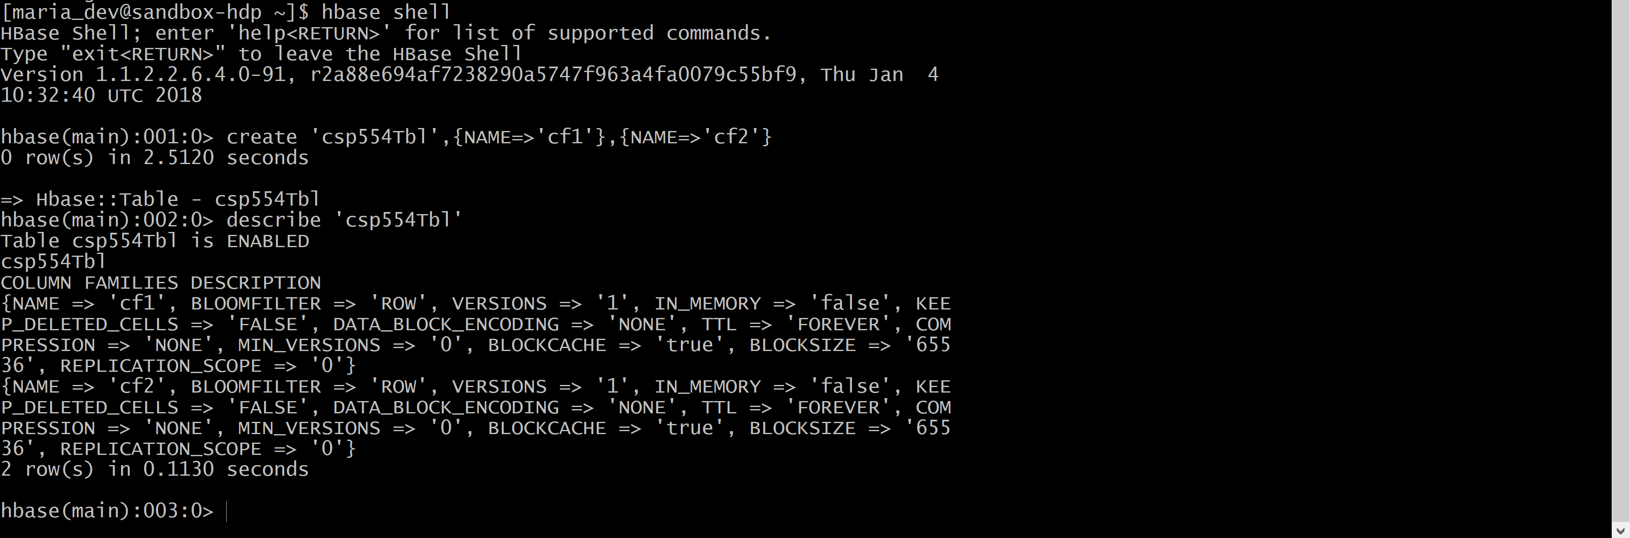

Exercise 2)

Put the following data into the table created in exercise 1:

|  |  |  |  |
| --- | --- | --- | --- |
| Row Key | Column Family | Column (Qualifier) | Value |
| Row1 | cf1 | name | Sam |
| Row2 | cf1 | name | Ahmed |
| Row1 | cf2 | job | Pilot |
| Row2 | cf2 | job | Doctor |
| Row1 | cf2 | level | LZ3 |
| Row2 | cf2 | level | AR7 |

Execute the SCAN command on this table returning all rows, column families and columns as the result of the exercise.

put 'csp554Tbl','Row1','cf1:name','Sam'

put 'csp554Tbl','Row2','cf1:name','Ahmed'

put 'csp554Tbl','Row1','cf2:job','Pilot'

put 'csp554Tbl','Row2','cf2:job','Doctor'

put 'csp554Tbl','Row1','cf2:level','LZ3'

put 'csp554Tbl','Row2','cf2:level','AR7'

scan 'csp554Tbl'

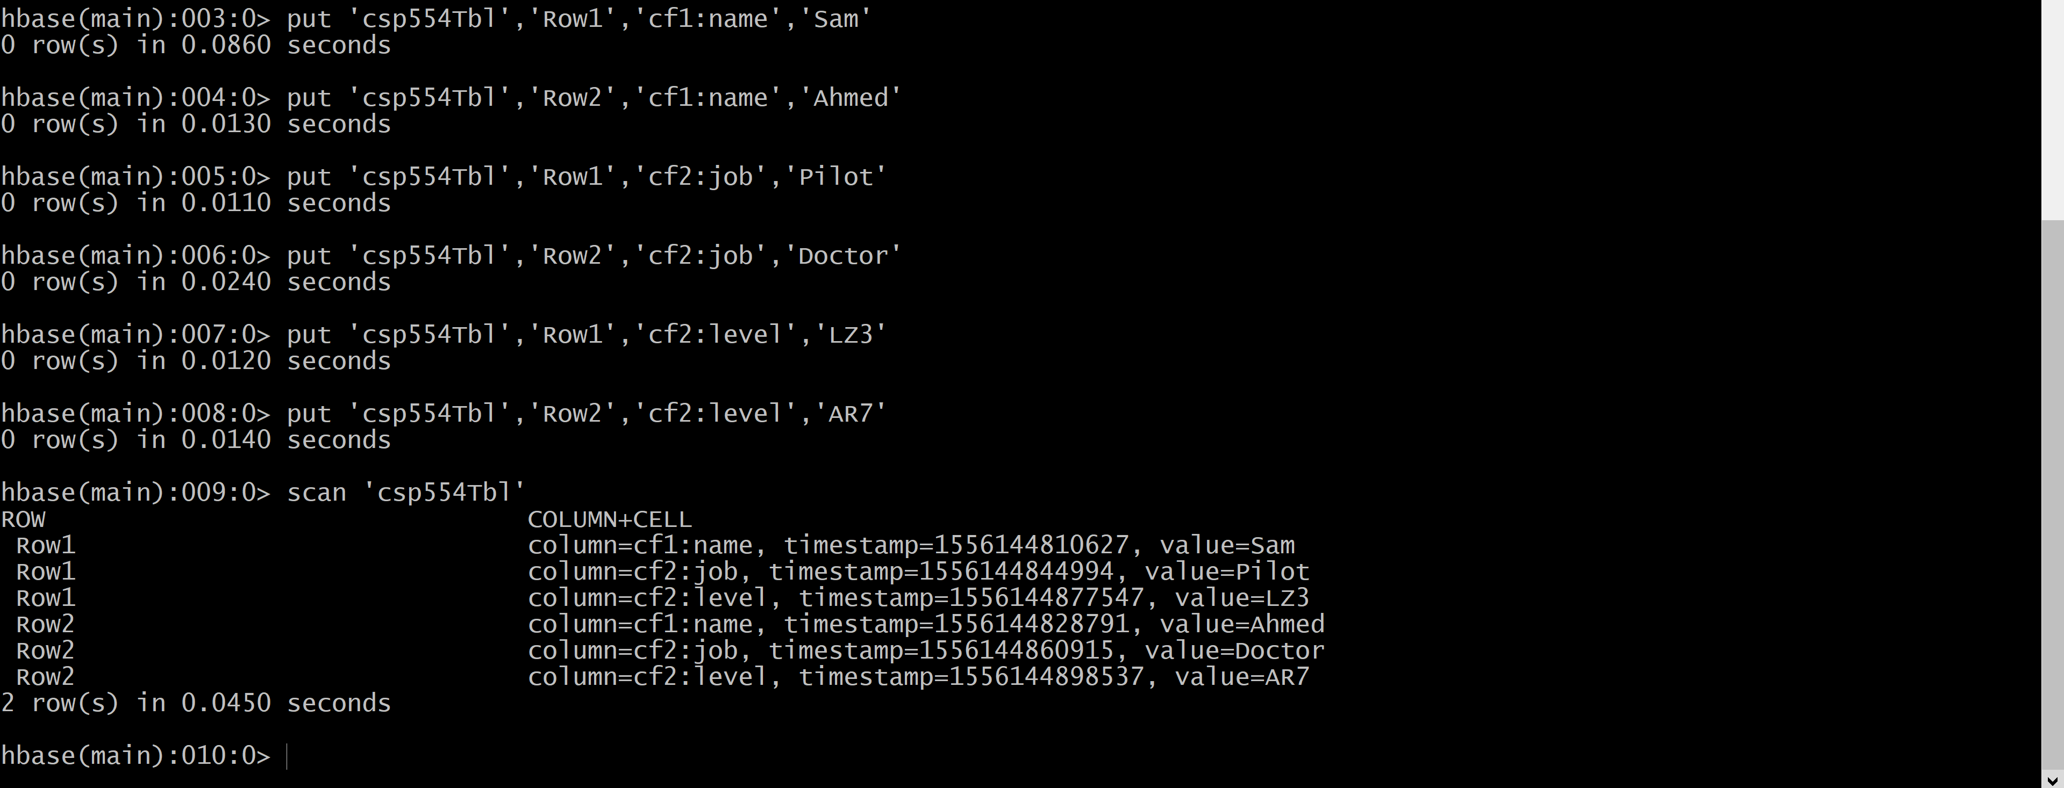

Exercise 3)

Using the above table write command that will get the value associated with row (Row1), column family (cf1) and column/qualifier (level). Provide the command and its result as the output of this exercise.

get 'csp554Tbl','Row1','cf2:level'



Exercise 4)

Using the above table write command that will get the value associated with row (Row2), column family (cf1) and column/qualifier (name). Provide the command and its result as the output of this exercise.

get 'csp554Tbl','Row2','cf1:name'



Exercise 5)

Using the above table write a SCAN command that will return information about only one row using the LIMIT modifier. Provide the command and its result as the output of this exercise.

scan 'csp554Tbl',{LIMIT=>1}

